Image | 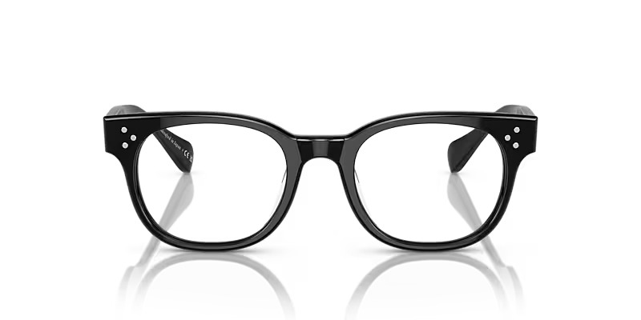
Brand | DIOR
Model Name | AFTON
Price | RS 2500
PRODUCT DETAILS

